**MONKEY POX VIRUS**

**Background**

Monkeypox is a rare disease caused by the monkeypox virus (MPV), which first occurred in monkeys kept for research in the late 1950s. It was first identified in humans in 1970 and since then has been reported in a number of countries in central and western Africa. Imported cases are usually associated with travel to endemic areas. The West African clade of the virus causes a milder illness compared to the Central African clade.

The UK Health Security Agency (UKHSA) initially confirmed a case of the West African clade on 7 May 2022. As of 26 June 2022 there were 1,076 laboratory confirmed cases in the UK, including confirmed cases in the East Midlands (Monkeypox outbreak: epidemiological overview, 28 June 2022 - GOV.UK (www.gov.uk)).

Monkeypox is usually a mild self-limiting illness, spread by very close contact with someone with monkeypox and most people recover within a few weeks. The virus does not spread easily between people and the risk to the UK population is low.

Spread of monkeypox may occur when a person comes into close contact with an infected animal (rodents are believed to be the primary animal reservoir for transmission to humans), human, or materials contaminated with the virus. The virus enters the body through broken skin (even if not visible), the respiratory tract, or the mucous membranes (eyes, nose, or mouth).

Person-to-person spread is uncommon, but may occur through:

* Contact with clothing or linens (such as bedding or towels) used by an infected person
* Direct contact with monkeypox skin lesions or scabs
* Coughing or sneezing of an individual with a monkeypox rash

The incubation period is between 5 and 21 days (average 6-16 days).

Clinical presentation

* The illness typically begins with fever, malaise, lymphadenopathy, headache. muscle aches, backache, swollen lymph nodes, chills, and exhaustion.
* 1-5 days after the fever a rash develops. This often begins on the face or genital area and then spreads rapidly across the body, including the genitals.
* The rash goes through various stages before forming a scab which falls off (see images below).
* People are infectious from the prodrome until healthy skin has developed under the scabs.
* The illness usually lasts 2-4 weeks.

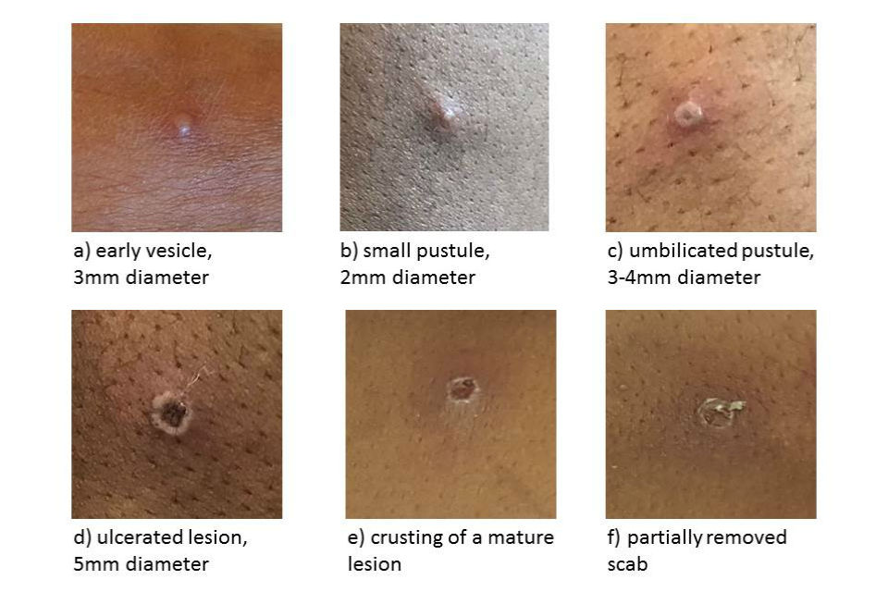

Treatment for monkeypox is mainly supportive. The illness is usually mild and most of those infected will recover within a few weeks without treatment.

[Smallpox vaccine, cidofovir, and tecovirimat](https://www.cdc.gov/poxvirus/monkeypox/clinicians/treatment.html) can be used to control outbreaks of monkeypox.

Vaccination against smallpox can be used for both pre- and post-exposure and is up to [85% effective in preventing monkeypox](https://www.who.int/news-room/fact-sheets/detail/monkeypox). People vaccinated against smallpox in childhood may experience a milder disease.

**Probable Case Definition:**

Unexplained rash on any part of their body **PLUS**, one or more of the below:

* acute illness with fever (>38.5)
* headaches,
* myalgia, arthralgia, back pain,
* lymphadenopathy

**AND**

* has an epidemiological link to a confirmed or probable case of monkeypox in the 21 days before symptom onset, **OR**
* reported a travel history to West or Central Africa in the 21 days before symptom onset, **OR**
* sexual history of men who has sex with men (MSM)