
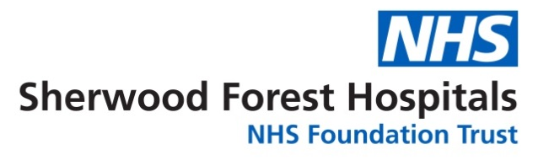


The SEXions team has put together some helpful websites for young people, young peoples’ workers, and carers.

Sexual health guidance/information

Really good information on sexual health for young people to access:

- My-Sexual-Health
(www.sfh-tr.nhs.uk/our-services/sexual-health/)
- Health for Teens
(www.healthforteens.co.uk)
- Brook
(www.brook.org.uk)
- Let’s Talk About Sex (www.sexwise.org.uk)
- Abortion clinics - information, advice and treatment
(www.bpas.org)
- Contraception Choices
(www.contraceptionchoices.org)

Support for children and young people

Helpful information for parents/carers is available on the NSPCC website. There is also information on reporting child abuse:

- www.nspcc.org.uk
- www.childline.org.uk

The SEXions team works in conjunction with the Nottinghamshire C Card service to provide free condoms and sexual health advice and support to young people aged 13-19.

For more information on the C Card service:
https://www.nottinghamshire.gov.uk/care/health-and-wellbeing/sexual-health/c-card-scheme

C-card now offers a postal service for young people to obtain condoms at:
www.ccardnottinghamshire.co.uk

Testing for sexually transmitted infections

HIV
If the young person is over 16 and living in Nottinghamshire, and concerned regarding the need for HIV screening, they can order a free postal HIV test at: www.freetesting.hiv

Chlamydia
If the young person would like access to a free postal Chlamydia test, this can be ordered at: www.freetest.me

Tests are posted out in an unmarked white plastic bag.

Wellbeing and mental health

KOOTH
This is a really helpful online service for young people to get support anonymously.
They have live online chats and the website has some great information to help support young people:
www.kooth.com

Young minds
Young minds are a charity for helping children and young people’s mental health. There is also information for parents:
www.youngminds.org.uk

Samaritans

If you require immediate support or are having a crisis, please call the Samaritans - telephone free on 116 123.
Sometimes it can be better to write down your feelings:
Email: jo@samaritans.org

LGBTQ+ Support

- Notts LGBT+ Network http://www.nottslgbt.com
- LGBT+ Service Nottinghamshire (lgbtplusnotts.org.uk)

We also have Instagram and Facebook. Follow our social media pages for up-to-date information and services:

- www.instagram.com @mysexualhealthkmh
- www.facebook.com @MSHSFH

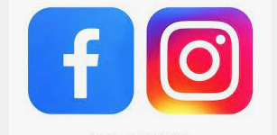

COVID-19 important notice

In view of the COVID-19 pandemic, My-Sexual-Health will require all attendees to book a telephone consultation for our service via our central booking number to allow appropriate triage.
For more information on the current situation visit: www.sfh-tr.nhs.uk/our-services/sexual-health/

Further sources of information

NHS Choices: www.nhs.uk/conditions
Our website: www.sfh-tr.nhs.uk

Patient Experience Team (PET)
PET is available to help with any of your compliments, concerns or complaints, and will ensure a prompt and efficient service.

King’s Mill Hospital: 01623 672222
Newark Hospital: 01636 685692
Email: sfh-tr.PET@nhs.net

If you would like this information in an alternative format, for example large print or easy read, or if you need help with communicating with us, for example because you use British Sign Language, please let us know. You can call the Patient Experience Team on 01623 672222 or email sfh-tr.PET@nhs.net.

This document is intended for information purposes only and should not replace advice that your relevant health professional would give you.

External websites may be referred to in specific cases. Any external websites are provided for your information and convenience. We cannot accept responsibility for the information found on them.

If you require a full list of references for this leaflet, please email sfh-tr.patientinformation@nhs.net or telephone 01623 622515, extension 6927.

To contact a member of the SEXions team.
To be completed by the Communications office
Leaflet code: PIL202104-01-SRGI
Reviewed January 2023 / Review Date: January 2025
Ashfield & Mansfield: Claire Smith & Phil Eardley: 07990 585642

Newark & Sherwood: Sarah Constable & Emma Calhabeu: 07580 749522

Email: sfh-tr.sexions@nhs.net

