Employee: Job Title:
Line Manager/ Appraiser:

Job Title:

Department: Department:

Employee Tips:
- This document is about your development and reflections.
- Include key points you'd like to discuss in the 'employee notes before' boxes.
- Bring the document along, your Manager will complete this on the day with you.

Care Values
Communicating and working together
C
We will work as one compassionate and inclusive team, involving, informing and listening to all colleagues and local communities.
Aspiring and improving
A
We will choose to work or be cared for by Sherwood as we focus on improving patient care and staff well-being.

Respectful and caring
R
We will show kindness to all, embrace diversity and challenge inappropriate behaviours.

Efficient and safe
E
We will be consistent and do the right thing at the right time, first time.
Date of Conversation:

Manager Tips:
- This is a tool to support the conversation between you both.
- Allow time for you both to prepare, two weeks is recommended.
- Include key points of the discussion in the manager sections on the day.

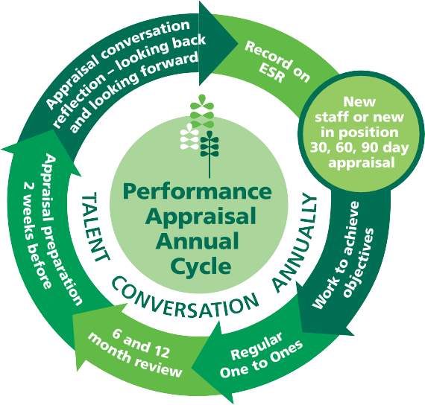
Annual Cycle

Do you feel able to ask for and receive support from colleagues and managers? Including a Wellbeing Conversation yes / no, if no what would help? Scan the QR code for the SFH Wellbeing and Welfare Support page.

Employee: Notes before

Before the Appraisal begins: How are you? - It's okay to reschedule, ensure it's the right time for the conversation.
Manager: Ask and capture key points below

Date started in post:

Local Induction completion:
Expectations of the role clarified:

Mentor / buddy agreed and in place (if needed):
90
First 90 Days in Role Including staff transferred internally or returning after 12 months
If not, move to Section 1

Employee: Consider and bullet point notes before to discuss on the day.

Manager: These are to support the employee’s induction. Documenting a summary of the chat and agreed actions is good practice.

30 Day Chat - How is it going? Any further support or queries?
Chat date:

Manager: Verbally give feedback, capture key points below
Employee: Notes before

60 Day Chat - Identify any additional support required and both discuss and agree on performance objectives for the year ahead. Write these on the next section.

Chat date:

Manager: Verbally give feedback, capture key points below
Employee: Notes before
90 Day Chat - How is it going? What's gone well? What are you most proud of?
Any challenges and further support? Chat date:
Manager: Verbally give feedback, capture key points below
Employee: Notes before

Performance Objectives for the year - Agree on performance objectives for the next 12 Months. Ensure they are specific, measurable, achievable, realistic and have a timeframe.
90
First 90 Days in Role Including staff transferred internally or returning after 12 months
If not, move to Section 1

Performance Objectives (Task) Link these to your role, the team and strategic priorities | How will you do this? What support is needed? | When

Next Work through, discussing at 1-2-1's and the 6-Month Review. When your Appraisal is due, move to Section 1: Looking Back

Employee: Consider and bullet point notes on what you would like objectives for the year to be.

Section 1: Looking Back

Successes and Achievements - What's gone well? What are you most proud of? What do you like about your role?
Manager: Verbally give feedback, capture key points below
Employee: Notes before
Performance Objectives - Have they been achieved? Any challenges and key learnings?
Manager: Verbally give feedback, capture key points below
Employee: Notes before
Personal Development - Have they been achieved? Any further development you have completed? Any challenges and key learnings?
Manager: Verbally give feedback, capture key points below
Employee: Notes before
Emerging and Current Leaders - How have you engaged, shared the vision and developed the team? Any further support needed?
Manager: Verbally give feedback, capture key points below
Employee: Notes before

Next - Once completed continue to Section 2: Looking Forward - New Objectives

Employee: Consider and bullet points notes in the new performance objectives before.

Section 2: Looking Forward - New Objectives

Complete Before: New Performance Objectives - Consider what you would like your objectives to be for the next 12 Months.
Employee: Notes before
Day of Discussion: New Performance Objectives - Agree on performance objectives for the next 12 Months. Ensure they are specific, measurable, achievable, realistic and have a timeframe.

Performance Objectives (Task) Link these to your role, the team and strategic priorities | How will you do this? What support is needed? | When

Next - Once completed continue to Looking Forward - Personal Development

Employee: Consider and bullet point notes in personal development section before

Section 2: Looking Forward- Personal Development

Complete Before: Personal Development - Consider training opportunities for the next 12 Months to help you reach your full potential
Employee: Notes before
Personal Development Plan - Discuss and agree steps that help you develop.

Area for development:  The knowledge skills or behaviour to help you to your job better | How will you do this? What support is needed? | When
Talent Conversation - Discuss and agree your 2 year plan that helps you develop and share knowledge with others.
Manager: Verbally give feedback, capture key points below
Next - Once completed continue to Section 3: Final comments and sign off

Final Discussion Comments

Section 3: Final Comments and Sign off

Date:
Signature:
Date:
Signature:
Manager Comments:
Employee Comments:

Manager to complete

Date logged onto ESR: 6 month review date:

Question | Y/N | Information
Subject to a live disciplinary sanction? |  | If yes then incremental pay progression should be stopped
Subject to sickness targets? |  | If yes then incremental pay may be stopped as part of the target discussion
100% compliant with their mandatory training? |  | If no then incremental pay progression should be stopped
Being / been managed in line with the formal stages of the Trust's Capability Policy? |  | Incremental pay progression will stop for the period of the formal stages
Completed their annual criminal convictions Model of Declaration form? |  | If any concerns are presented on the form contact Operational HR
Completed their annual declaration / submitted a nil return on the Declaration of Interest system? |  | All staff are required to annually review and update their declaration of interests. Bands 7 or above employees with nothing to declare, must submit a nil return.
Copy of the document been logged in the employees personal file?
Copy of the paperwork been given to the employee within 14 days of completion?

Next - Once completed have regular 1-2-1's and review at 6 Months

