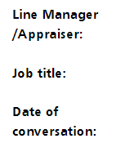

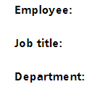

Employee Tips:
- A 1-2-1 is an informal chat to discuss: how you are, share achievements and identify if any support is needed.
- You may discuss development opportunities, review progress in your objectives and personal development.

Notes and Key Actions

Manager Tips:
- This is a tool to support the conversation between you both
- Include key points and any actions below.
- Questions you could ask: How are you? What's going well? Any challenges? What progress has been made with your objectives and personal development plan? Do you need any further support?

