Care during pregnancy, birth and the postnatal period during Covid-19
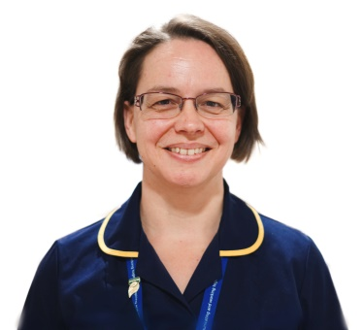
Due to the Covid-19 pandemic, we have had to make some difficult decisions about the way your maternity care is provided. We recognise that this will affect you all in different ways and we want to reassure you that the current measures are in place to ensure the safety of women, their babies and families, and our staff. These measures are reviewed daily, and in case of changes, we will provide you with an update. We will be working closely with the Nottingham & Nottinghamshire Maternity Voices Partnership to ensure information is shared with you as quickly as possible.
This update will include:
- General information about the Sherwood Forest approach to COVID 19
- Some national links to further information
- Your care during pregnancy
- Your care during labour
- Your care after your baby is born
At Sherwood Forest Hospitals the staff are a family. We are here for you, your baby and your families. We could never take the place of your loved ones, but we will do our best. We will care for you to the utmost of our ability, show you our compassion and our drive. We will step into all roles and be the hand you need. We want to provide you with the care and compassion we would hope for our own loved ones.
Thank you
Penny Cole
Divisional Head of Nursing & Midwifery
Women and Children’s Division

Please note that some of the photos included in this update were taken before social distancing measures were introduced. All of our staff including support teams and community midwives are trained and equipped with Personal Protective Equipment (PPE) to help keep you, your families and the staff protected.
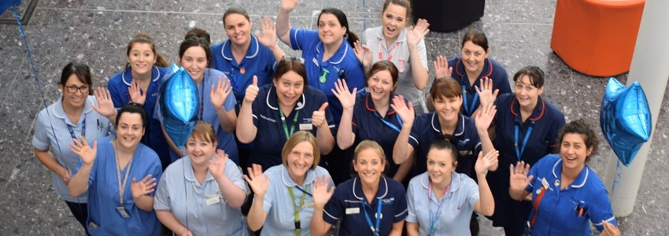
General information about the Sherwood Forest Hospitals approach

You will see that we are promoting social distancing on our sites by altering seating areas where we can, introducing ‘stop and wait’ points, and asking all patients who have symptoms of coronavirus (high temperature, a new, continuous cough and a loss or change to your sense of taste or smell) to stay at home.
In addition, in line with government guidance from 15 June 2020 all women and their partners are asked to wear a face covering or mask when attending the hospital.
We are providing telephone or video consultations where it is possible to do this, so that our clinics are less crowded.
All of our staff are trained in the use of personal protective equipment (PPE) including when and how this should be worn. If you have any questions about this please ask your midwife. We are following national guidance on PPE which is subject to change.
We have identified and equipped separate areas in the hospital to care for patients with Covid-19. Our maternity unit and neonatal unit also have separate isolation areas identified. We provide hand washing facilities and alcohol hand gel for use at the entrance to all wards and departments.
If you are worried about yourself or your baby, please get in touch. Your care will be provided by midwives (and doctors where necessary) in the normal way. We can make safe arrangements for you and your baby even if you have symptoms.

Links for further information:
https://www.nhs.uk/conditions/coronavirus-covid-19/
https://www.rcog.org.uk/en/guidelines-research-services/guidelines/coronavirus-pregnancy/
https://babylifeline.org.uk/home/covid19/
https://www.sfh-tr.nhs.uk/our-services/maternity/infant-feeding/
https://www.rcm.org.uk/media/3915/guidance-for-women-on-home-visits-4.jpg

Your care during pregnancy
Should I still attend my antenatal appointments in the community?
We want to take good care of you and your baby. Your appointments are essential to monitor the health of yourself and your baby. You should still attend antenatal appointments with your community midwife unless you have been told otherwise. You should wherever possible attend alone, but if you or a member of your household is experiencing symptoms of COVID-19, self-isolating or shielding please do not attend and contact the community midwife’s advice line on 01623 676170 for further guidance.
Will hospital appointments including scans still be running?
Antenatal care is essential so hospital appointments will still be carried out. The Trust is really pleased to inform you that women are now able to bring one adult family member or friend with them for their 12 week or 20 week routine scans. However women must still attend all hospital appointments and additional scans alone unless told otherwise. If you do need a telephone consultation, this will be arranged at the same time as your original hospital appointment. Please be aware if we telephone you it may show as an ‘unknown number’ so please answer as it may be one of our team trying to get in touch.
You can expect to be asked some personal questions so that the hospital team can identify you when they call, for example full name and date of birth. You will not be asked for any other information such as bank or credit card details.
If you would like to find out the sex of your baby during your scan, please ask your sonographer. This becomes part of the clinical process and the results will be discussed with you at the time and included in your pregnancy records as part of the documentation. Please remember that 100% accuracy cannot be guaranteed when determining the sex of the baby.

As antenatal classes are cancelled, is there any further information I can receive?
We are exploring online options to provide you with more antenatal and postnatal support. At the moment, we are using Zoom to conduct feeding support sessions online – to access these please ask your community midwife or contact the Lime Green team directly by emailing; Sfh-tr.infantfeeding@nhs.net, including your contact details and due date.
We hope to provide additional options to support antenatal education on line in the near future and will offer more information about this when it is available.
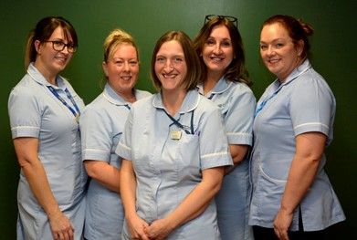

Patient Testing for COVID-19
In line with National Guidance any women who come in to hospital and need to stay will now be tested for COVID-19 . This will include women who are not showing any symptoms. The testing will be done via a swab taken from the nose and the mouth.
We will update all women and inform them if their result is Positive and what to do next even if you have been discharged home. Please remember that you may have a positive result and still not have any symptoms.

If you have any questions you can call still call and speak to a midwife on the number on your hand held records.

Your care during labour (including information about visitors)
Sherwood Forest Hospitals currently has a policy of one visitor per patient – there are specific exceptions to this including end of life care.
The maternity team welcomes birth partners and recognises how important it is for women to experience support and comfort from a trusted partner during labour and birth. Please make sure that your partner does not have any symptoms, high temperature, a new, continuous cough and a loss or change to your sense of smell or taste.
Please also be assured that we are reviewing our policies regularly and recognise that your experience during labour and birth is an important aspect of family life. We aim to respond quickly and appropriately to social distancing guidelines and all of the details below are subject to change.
Labour:
Please initially come in for an assessment on your own, we will ask your birth partner to wait elsewhere while a plan is made. When you are assessed as in established labour, your birth partner is welcome to join you. You are unable to bring any other children with you into the hospital building. Please make arrangements for care of other children in advance of your due date. If this isn’t possible, then your partner will have to remain at home for childcare and you can arrange an alternative birth partner who is symptom-free. If you are unable to bring a birth partner, then please know that, as always, our midwives are there to fully support you throughout your labour and birth.
Our birth pool is still available as long as you do not have symptoms of or have been confirmed to have Covid-19.

Induction of labour:

If you are coming in for an induction of labour, your birth partner is now able to attend with you. When in established labour you will be transferred to the birthing unit and your birth partner is able to remain with you. Please be aware that partners are asked to wear face masks or face coverings when a midwife is present in the room and are to remain in the room as much as possible when on the Maternity Unit. Partners will not be supplied with meals whilst they stay on the Unit.
Please note that it can take around 24-48 hours for labour to start after an induction process, your midwife can tell you more about this.
Caesarean section:
If your Caesarean section is planned, please follow the instructions that you receive from the team (midwives and doctors) in the days leading up to your operation.
On very rare occasions it may be necessary to change the date of your operation at very short notice, we will keep you informed on an individual basis.
Your birth partner is welcome to join you on the day of your Caesarean section and can be present during the operation as is our normal practice.
If you need to have a Caesarean section as an emergency, your birth partner can be present during the operation as is our normal practice.
For planned and emergency Caesarean sections there may be rare occasions when your partner is not able to be present. You will be kept informed by the team looking after you.
Women will not be required to wear a mask whilst they are within their own room / bay whilst they are an inpatient but will be expected to wear a mask when moving around the unit and using communal areas.

Please be assured that at SFHFT we continue to work within local and National Guidance to regularly review our maternity visiting restrictions. Any additional measures are approached systematically including risk assessments, ward and department layout and capacity for social distancing and the local COVID-19 response level.

Home births
We are pleased to update you that we have now returned to a full home birth service at Sherwood Forest Hospitals. However women who are known to be COVID-19 positive or have symptoms are advised to have their baby in a hospital environment.

If you are planning a home birth please make sure your midwife is aware so that individual plans and risk assessments can be fully discussed and completed.

If you are worried about coming into hospital to give birth, please talk it through with your midwife. Our Sherwood Birthing Unit offers a safe and private environment, including birth pool availability, and a team of experienced and supportive midwives. We can help you to make an alternative birth plan if this is required.

Your care after your baby is born
After your baby is born, including if you have a Caesarean section, you and your birth partner can have some private time together on the Sherwood Birthing Unit. This is usually a few hours. You may be able to go home together from here, and we would encourage you to do this if possible. Alternatively, mum and baby will be transferred to the maternity ward and partners will need to go home at this time until discharge from the maternity ward can be arranged.
Going home (discharge): As a team we are trying to discharge you and your baby home as effectively and safely as possible as long as you both are fit and well. If you need an overnight stay with us, then we will provide you with the highest standard of care and compassion. We understand this is a daunting experience but if assistance is needed just press the call buzzer or find a member of the team and we will be happy to help you. If you need to stay in longer, we will do our best to get you a side room.

There is a free WI-FI service at King’s Mill Hospital so that you are able to Facetime or Skype family members. Please be respectful if you are in a bay with other women.
When you are discharged, your partner/family member is welcome to come and collect you. Our staff will help you and your baby to meet your partner at the door of
the maternity unit or downstairs in the main foyer. Please make sure whoever is collecting you has no symptoms of Covid-19 or is currently self-isolating/shielding. They will need to wear a face mask or face covering to collect you and ensure regular hand washing is practised.

Registering the birth:
There is currently a limited registration of birth service
You are however able to claim Child Benefit without having your baby registered at this time.
Please make sure you keep checking the government website to see when and how you are able to register your baby’s birth. Below are links for Nottinghamshire and Derbyshire:
https://www.nottinghamshire.gov.uk/births-deaths-marriages-and-civil-partnerships/births/book-appointment
https://www.derbyshire.gov.uk/community/births-deaths-marriages-and-civil-partnerships/births/registering-a-birth.aspx

Postnatal visits:
Community Midwives at Sherwood Forest Hospitals have now returned to providing postnatal care in the community as they were before the COVID-19 pandemic. Women and babies will be seen in a mixture of venues including home, GP clinic and children’s centres.

Staff will wear PPE to reduce risks for you, your family and our staff. For ways to prepare for your midwife home visit please see the guidance from the Royal College of Midwives in the link below:
https://www.rcm.org.uk/media/3915/guidance-for-women-on-home-visits-4.jpg

Day 10-14:
A health visitor will make telephone contact with you and arrange for you to attend a clinic to weigh your baby. Please take this opportunity to have your baby weighed.
Other issues
Physiotherapy referrals:
Your midwife/GP can still refer you to physiotherapy for pregnancy related aches and pains.
You will NOT need to attend hospital for a physiotherapy appointment.
The physiotherapy team will ring you to complete a telephone assessment. From there, they have lots of great electronic resources they can share with you as indicated.
For common aches and pains including pelvic girdle pain please see link https://pogp.csp.org.uk/system/files/publication_files/POGP-PGP(Pat)(UL).pdf
If you sustain a serious tear (called a 3rd degree tear) during your birth, you will receive a call from the physio team to arrange a face-face assessment at around 6 weeks postnatal. You should attend this appointment alone (without your baby) and will be given information about where to attend when the appointment is arranged. The clinician will want to examine your tear during this session. At the end of the appointment they will consider very carefully whether you need to attend for a follow-up appointment, or whether subsequent appointments can be completed over the phone.

Perinatal support for Black, Asian and minority ethnic Women during the COVID-19 Pandemic:
We already know from research that women and babies from a Black, Asian and Minority Ethnic (BAME) background are more at risk in general during and after pregnancy than White women and babies. These risks are still very small, but it is important that you seek help if you think something isn’t right with you or your baby.
Recent findings also show that women from Black, Asian and Minority Ethnic backgrounds are more affected by COVID-19 than White women. While most pregnant women with COVID-19 experience mild or moderate symptoms, a small proportion of pregnant women with COVID-19 have needed admission to hospital for

treatment. Asian women are four times more likely than White women to be admitted to hospital with COVID-19 during pregnancy, while Black women are eight times more likely. If you have COVID-19 symptoms, it is important that you call 111 and they will be able to advise you.

Worries/concerns:
Please contact the numbers on your handheld notes as normal if you have any worries or concerns, a midwife will offer advice and support as to whether you need assessment.
Please ask your partner, family member, friend who has no symptoms of Covid-19 or is not currently isolating to bring you and wait in the car for a plan to be made.
On some occasions it may be that the midwife may feel it is reasonable for your birth partner to attend with you and wait before coming onto the birthing unit.

THANK YOU
Your SFH Midwifery Team

